NOOR UL SHIFA
59239
WAD LAB 2

TASK #01
<!DOCTYPE html>
<html lang="en">
<head>
<meta charset="UTF-8">
<meta name="viewport" content="width=device-width, initial-scale=1.0">
<title>Document</title>
</head>
<body>

<form>
<label for="firstName">First Name:</label>
<input type="text" id="firstName" name="firstName"><br>

<label for="lastName">Last Name:</label>
<input type="text" id="lastName" name="lastName"><br>

<label for="city">City:</label>
<input type="text" id="city" name="city" value="Karachi"><br>

<label for="zipCode">Zip Code:</label>
<input type="number" id="zipCode" name="zipCode" maxlength="4"><br>

<label for="dob">Date of Birth:</label>
<input type="date" id="dob" name="dob"><br>

<input type="submit" value="Submit">
</form>
</body>
</html>
OUTPUT:
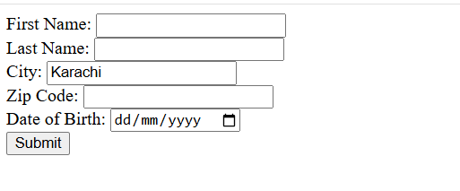

TASK #02
<!DOCTYPE html>
<html lang="en">
<head>
<title>LAB1</title>
</head>
<body>
<table style="width:100%" border=1>
<tr>
<th>First name</th>
<th>Sap id</th>
<th>CGPA</th>
</tr>
<tr>
<td>Eman Asrat</td>
<td>12345</td>
<td>3.80</td>

</tr>
<tr>
<td>Habiba</td>
<td>13456</td>
<td>3.80</td>

</tr>
<tr>
<td>Ahmna</td>
<td>15780</td>
<td>3.50</td>
</tr>
<tr>
<td>Noor </td>
<td>19239</td>
<td>3.11</td>
</tr>
<tr>
<td>Iqra</td>
<td>10987</td>
<td>3.30</td>
</tr>
</table>
</body>

</html>

OUTPUT
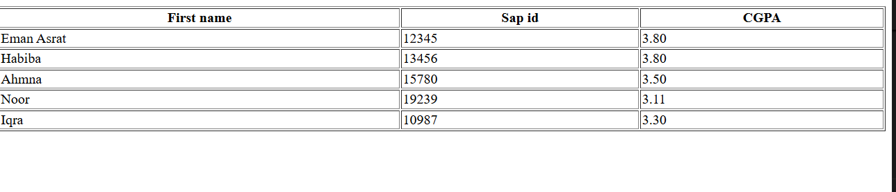

TASK # 03
<!DOCTYPE html>
<html lang="en">
<head>
<meta charset="UTF-8" />
<meta name="viewport" content="width=device-width, initial-scale=1" />
<title> Registration Form</title>
</head>
<body>

<h1>Registration Form</h1>

<form>
<label for="fullname">Full Name:</label><br>
<input type="text" id="fullname" name="fullname" required><br><br>

<label for="email">Email Address:</label><br>
<input type="email" id="email" name="email" required><br><br>

<label for="username">Username:</label><br>
<input type="text" id="username" name="username" required><br><br>

<label for="password">Password:</label><br>
<input type="password" id="password" name="password" required minlength="6"><br><br>

<label for="confirmPassword">Confirm Password:</label><br>
<input type="password" id="confirmPassword" name="confirmPassword" required minlength="6"><br><br>

<a href="login.html">Sign in</a></p>
</form>

</body>
</html>
OUTPUT
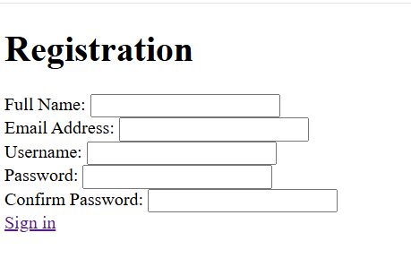
TASK # 04
<!DOCTYPE html>
<html lang="en">
<head>
<title>SEASONS</title>
</head>
<body>
<h1>Seasons</h1>
<h2>Spring</h2>
<p> Spring is the season of new beginnings, when nature wakes up after winter. <br>Trees turn green, flowers bloom, and the air feels fresh and pleasant.. </p>
<h3>Summer</h3>
<p>Summer is the warmest season of the year, full of sunshine, long days, and vibrant energy. </p>

</body>
</html>

Output:
